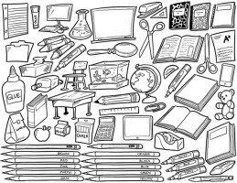
Donations
Needed!

Ms. Spiegel is a new teacher and she needs help acquiring supplies!

Most Important:

- Tissue boxes
- Markers! (Any and all varieties)
- Colored Pencils
- Sharpie Markers (all colors and sizes)
- Glue sticks
- Masking Tape
- BOOKS for the classroom library!!

Other Supplies:

- Electric pencil sharpeners
- College ruled loose leaf paper
- Duct Tape (all colors)
- Art Supplies of all varieties

If you can donate any of these things, or anything else you think we could use, please bring them to room 308 any time.

THANK YOU!!!

