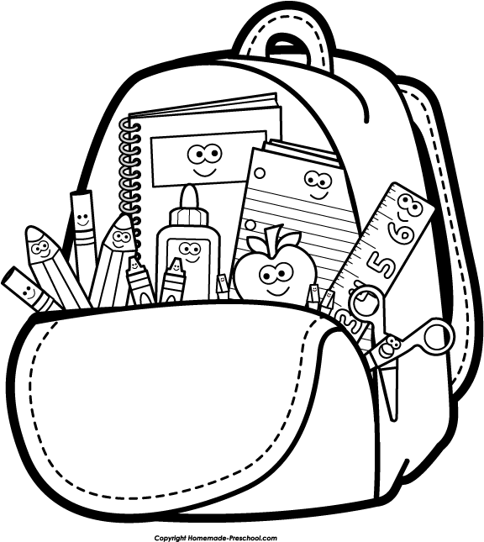
Hello
Spiegel Core Parents!

My name is Jasmine Spiegel, and I can't tell you how excited I am to be here at da Vinci! This year is going to be creative, challenging, and fun, and I am looking forward to the opportunity to learn with this group of students. Because I am new to the school and just starting out in my career, I wanted to take a moment to share with you a little information about who I am as a person and as a teacher.

I grew up here in the Portland area as an obsessively avid reader and writer with a passion for understanding what makes humanity tick. I was lucky enough to attend the Northwest Academy for the last three years of high school, where I focused on all forms of writing and darkroom photography. Later, I received a BA in Social Science with an Anthropology concentration and a minor in photography from Marylhurst University. In July, I graduated from the MAT program at Lewis & Clark College, where my primary focus was English Language Arts. What I may lack in years of experience, I believe I more than make up for in passion and enthusiasm!

It is especially important to me that each student feels seen and heard in my classroom. I pledge to help create a community that encourages open and honest learning and growth, where each person in the room recognizes their worth and contribution to this unique group of learners. I want students to see the strength of their own voices and the importance of their ideas. In my classroom, we are all teachers and students working together to solve interesting mysteries and unlock the potential and power of knowledge.

In order to help build a strong classroom community, it is my hope that you will not mind filling out a brief survey about your student. I am interested in learning your perspective on your child, and I am hoping to hear your thoughts on how to make each student feel individually productive and involved in the classroom. I have enclosed the survey inside this packet, and returning it to me will allow me to check off that every parent has received this information. Thank you in advance for helping to build our community!

This year in Social Studies, we will be focusing on Ancient Civilizations, including but not limited to Sumer, China, Egypt, India, Mesopotamia, Greece, and Rome. As well as learning about how these cultures formed and functioned, students will study the art, philosophy, and exploration that made each one unique. Often, we will discuss these concepts through the lens of their impact on the modern world, and students will reflect on their own relevant personal experiences.

There is more information included in the packet about the reading and writing plan for the year. Students will be reading a variety of short texts, both fiction and nonfiction, and a few longer novels and plays. I find that short stories provide the opportunity for in-depth exploration into many of the same literary elements and experiences we find in novels, and it allows us to read these texts within one or two class periods in order to help us build up to more complex literary analysis.

It is my expectation that students will read a variety of texts, create at least one major Social Studies project, and write at least one essay each quarter. In addition to these larger assignments, students will work on several smaller writing and Social Studies pieces. Students will participate in at least one book group this year, though they will study some shorter texts in groups as well.

I do expect that every student in my core class will read at least 30 minutes per night. Students should all have choice books and they should always bring these books to class for Sustained Silent Reading time. Students are welcome to access our classroom library for reading options, and we're right down the hall from the da Vinci library, too!

For information about what is happening in core, please check out my website: http://spiegelcore.weebly.com. I will update the blog each week, and I will also include digital copies of all the handouts students need in the class. If you do not have regular access this information, please let me know--I will make sure we find a way to keep you up to date on everything that is happening.

Please make sure your student has a planner/calendar! This is SUPER IMPORTANT! If your student does not want to use the planner provided by da Vinci, they MUST have their own. This will help ensure that students form productive study habits before they enter high school. I appreciate your help making sure that each student is using a calendar to track assignments and events!

Thank you so much for taking the time to read this letter and the other materials provided in the packet. I know this seems like a lot of information, but it is important to me that parents know what is happening in core and that we are all working together to build a strong community of learners, at school and at home.

Don't hesitate to contact me at school 503.916.5356, at home 503.997.7853, or via email at jspiegel@pps.net. I will be available to students and parents during seventh period, and by appointment during lunch and after school.

I can't wait to meet you at Back to School Night on September 16th!

Looking forward to a great year,

Jasmine Spiegel
Language Arts/Social Studies
da Vinci Arts Middle School

*Please return parent survey by Friday, September 12th. Thank you!
*Also, check out the plea for donations included in the packet. I appreciate anything you can provide!!

