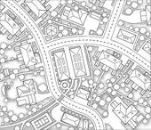
Draw a Map
of your Neighborhood

It can be the area you live in now, your childhood neighborhood, the area around your grandma's house, or another place that feels like home
(whatever area you connect to most)

DRAW:
*One block radius
*COLOR! (pencil/crayon/marker/etc)
*From a bird's eye view perspective
*Label where you live or lived
*Create a Key of important locations and landmarks
*Mark at least five places on your map
where stories exist (ask your parents, too)
*Label Map "My Neighborhood" with your
first and last name.

MAP DUE WEDNESDAY, SEPTEMBER 17th!

